Rank the following solutions to climate change
https://edition.cnn.com/interactive/2019/04/specials/climate-change-solutions-quiz/

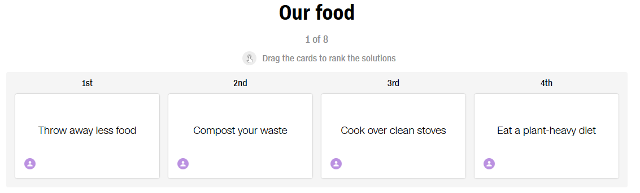
1. __________________________________________________________________________
2. __________________________________________________________________________
3. __________________________________________________________________________
4. __________________________________________________________________________

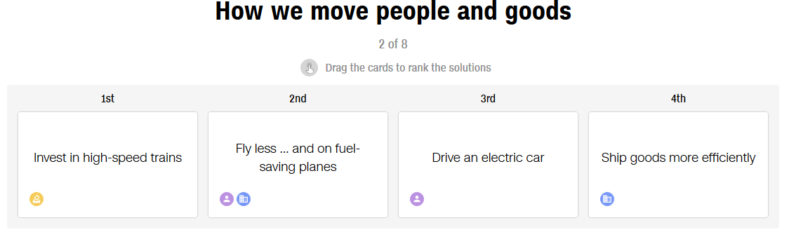
1. __________________________________________________________________________
2. __________________________________________________________________________
3. __________________________________________________________________________
4. __________________________________________________________________________

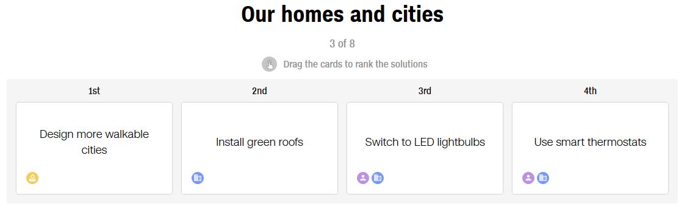
1. __________________________________________________________________________
2. __________________________________________________________________________
3. __________________________________________________________________________
4. __________________________________________________________________________
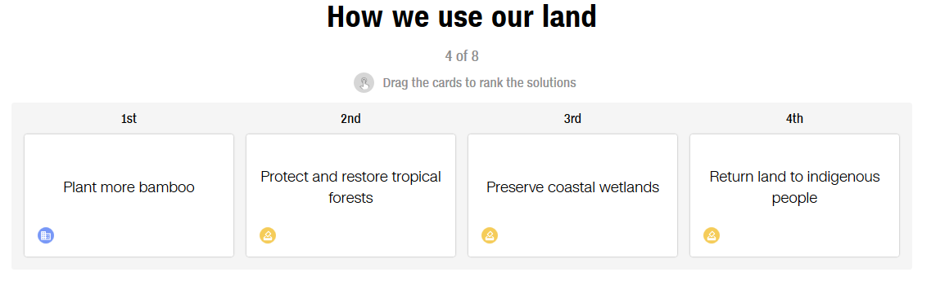
1. __________________________________________________________________________
2. __________________________________________________________________________
3. __________________________________________________________________________
4. __________________________________________________________________________

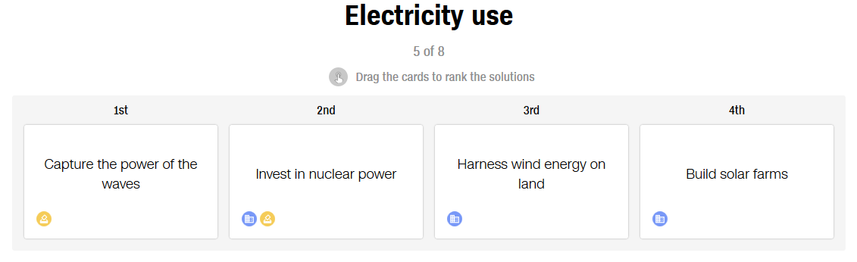
1. __________________________________________________________________________
2. __________________________________________________________________________
3. __________________________________________________________________________
4. __________________________________________________________________________

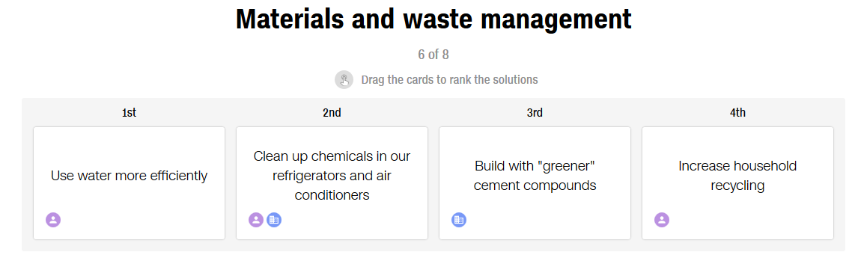
1. __________________________________________________________________________
2. __________________________________________________________________________
3. __________________________________________________________________________
4. __________________________________________________________________________
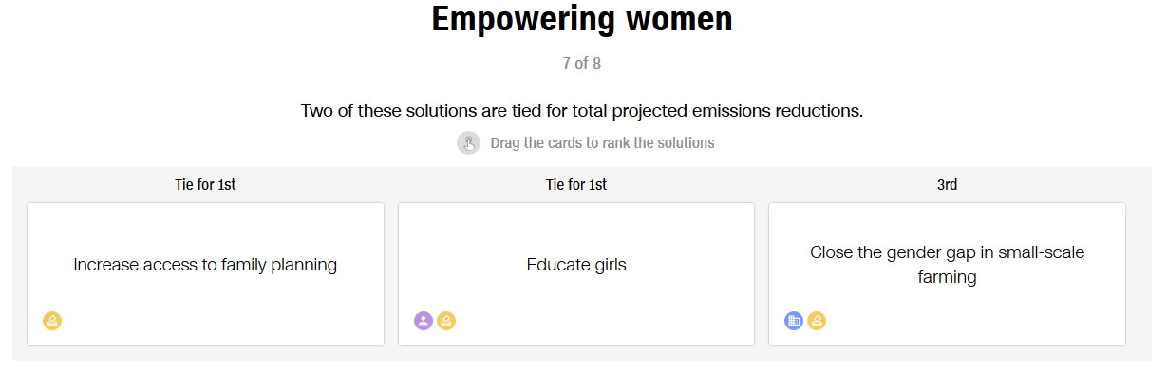
1. __________________________________________________________________________
2. __________________________________________________________________________
3. __________________________________________________________________________
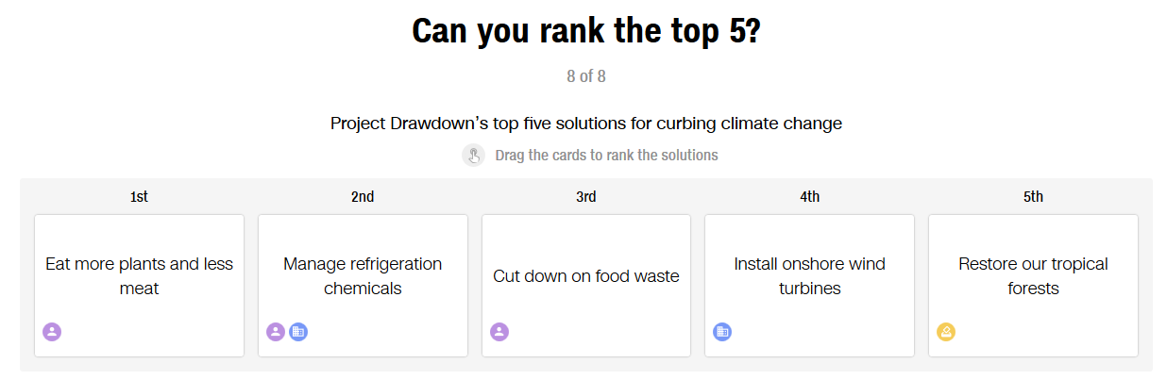
1. __________________________________________________________________________
2. __________________________________________________________________________
3. __________________________________________________________________________
4. __________________________________________________________________________
5. __________________________________________________________________________

Vocabulary
throw away : jeter
waste : déchets
stove : cuisinière, réchaud
ship : transporter, expédier
goods : produits, biens
roofs : toits
passer à : switch to
coastal wetlands : zone humides littorales
harness : exploiter, maîtriser
solar farm : parc solaire
cement compounds : composés de ciment
household : domestique (lié à la maison)
close :mettre un terme à
gender gap : inégalités entre les sexes
onshore : sur terre (=/= offshore)

https://edition.cnn.com/interactive/2019/04/specials/climate-change-solutions-quiz/

The most effective ways to curb
climate change might surprise you

The planet is barreling (= foncer) toward 1.5 degrees of global warming as soon as 2030 unless (= à moins que, sauf si) we enact ( = promulguer, décréter) “unprecedented changes in all aspects of society,” a dire (= pressant, urgent) United Nations report warned (=alerter) in October.
To reduce our impact on the climate and avert -(= éviter) disaster, it’s going to take more than switching to (= passer à) high-efficiency light bulbs (=ampoules). But the most effective ways that individuals (= particuliers) , policymakers (=législateurs) and businesses (= entreprises) can reduce our carbon footprint (=empreinte) might surprise you.
Let’s see how much you know about what can be done to fight climate change.
The group Project Drawdown has ranked (=classer) the most effective climate change solutions, and we’ve separated some of the top ones by category.
Actions are labeled (=étiquetées) to indicate whether (=si) they can be implemented (= mises en œuvre) by individuals, companies or policymakers.

OUR FOOD
According to Project Drawdown, if all of the world’s cattle (= bétail) formed their own nation, they would be the planet’s third-largest emitter of greenhouse gases, so eating less meat — especially beef — is good for the planet.

But throwing away less of what we eat is an even more impactful way to reduce carbon emissions. A third (= un tiers) of all food that we raise (= élever) or grow (= faire pousser) never makes it (= n'arrive pas) onto our plates, and that waste accounts for around 8% of global emissions, according to Drawdown’s analysis.

But, since there is food wasted all along the supply chain (= chaîne logistique) , eating less meat is probably the most effective way individuals can fight climate change.

HOW WE MOVE (= déplacer) PEOPLE AND GOODS (= produits, biens)
The planes and ships that crisscross (= sillonner) the globe use a lot of energy, and adopting more efficient shipping (= transport) practices and flying fuel-saving planes would keep a lot of CO2 out of the atmosphere.

But if more people started driving electric vehicles, it would cut (= réduire) carbon emissions even more. According to Project Drawdown’s analysis, if just 16% of the miles we drive were traveled in an electric-powered vehicle instead of a gas-powered one, it could keep 10 gigatons of carbon emissions out of the air.

OUR HOMES AND CITIES
Designing cities that prioritize walking helps cut emissions from driving, but according to Project Drawdown, some even more impactful ways to reduce energy use can be found at your local hardware store (= quincaillerie) .

LED lightbulbs (= ampoules) cost more, but they use far less energy than incandescent and compact fluorescent bulbs, and they last (=durer) longer. Installing smart (= intelligent) thermostats can also offer major climate benefits (= avantages) .

HOW WE USE OUR LAND
All forests are critical to storing (=stocker, emmagasiner) carbon, but none more than tropical forests. But, due to deforestation, they now cover less than 5% of Earth’s landmasses.

Restoring the world’s tropical forests could keep an estimated 61 gigatons of CO2 out of the atmosphere, Project Drawdown’s analysis shows. And though technically a grass (= herbe, gazon, prairie) , bamboo is also a superstar at storing carbon and thrives (= bien pousser) on degraded land, making it a logical climate change solution.

ELECTRICITY USE

Nuclear is often touted (= présenté avantageusement) as a “green” electricity source, but its capacity to curb (=réduire) global warming pales (= pâlir) in comparison to renewable sources. And while solar has potential as a dominant electricity source in the future, Project Drawdown says investing in onshore (= terrestre) wind farms (= parcs d'éoliennes) offers the greatest reduction in CO2 emissions.

Wind farms can also be built quickly, and the land they sit on can be used for farming (=agriculture) or grazing (= pâturage) simultaneously.

MATERIALS AND WASTE MANAGEMENT

Recycling, using less water and switching to cleaner cement (= ciment) would all help slow climate change. But the chemicals used in our refrigerators and A/C units (=climatiseurs) trap (= piéger, emprisonner) thousands of times more heat (= chaleur) than CO2, so containing (=retenir, contenir) them is essential to stopping global warming.

If we prevent (= empêcher) refrigerants from leaking (= fuir) and switch to using cleaner chemicals, it would be like keeping nearly 90 gigatons of C02 out of the atmosphere, according to Project Drawdown’s analysis.

EMPOWERING (= valoriser, donner du pouvoir à) WOMEN

What does educating women and investing in family planning have to do with global warming? Well, a lot actually. According to Project Drawdown, women with more education tend to have fewer (= moins de) children, which could slow population growth (= croissance) and, in turn, curb (= réduire) carbon emissions.
TEACHER (answers according to DrawDown project online)

OUR FOOD
Throw away less food
Eat a plant-heavy diet
Cook over clean stoves
Compost your waste

HOW WE MOVE (= déplacer) PEOPLE AND GOODS (= produits, biens)
Drive an elctric car
Ships goods more efficiently
Fly less and on fuel-saving-planes
Invest in high-speed trains

OUR HOMES AND CITIES
Switch to LED bulbs
Design more walkable cities
Use smart thermostats
Install green roofs

HOW WE USE OUR LAND
Protect and restore tropicla forests
Plan more bamboo
Return land to indigenous people
Preserve coastal wetlands

ELECTRICITY USE
Harness wind energy on land
Build solar farms
Invest in nuclear power
Capture the power of the waves

MATERIALS AND WASTE MANAGEMENT
Clean up chemicals in our refrigerators and air conditioners
Build with 'greener' cement compounds
Use water more efficiently
Increase household recycling

EMPOWERING (= valoriser, donner du pouvoir à) WOMEN
Educate girls
Increase access to fmaily planning
Close the gender gap in small-scale farming

CAN YOU RANK THE TOP 5?
Manage refrigeration chemicals
Install onshore wind turbines
Cut down on food waste
Eat more plants and less meat
Restor our tropical forests

Oral activity :rewrite the sentences according to what a 'crazy' global warming sceptic would advise?
Throw away less food → Throw away more food!

