Trump ‘Murinal’

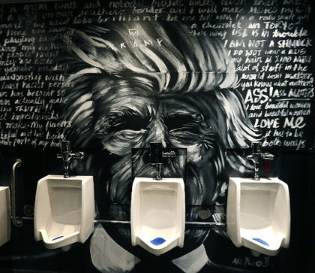
One piece of protest art, which I particularly like, was made in 2016 in response to Donald Trump when he was still a candidate for the 2016 presidential elections in America. This was before he had won the election, before he became President, but he had already upset a lot of people, and somebody decided to make a ‘murinal’ about him. A ‘murinal’ is a combination of two words – ‘mural’ and ‘urinal’ – and I like this one because I think it’s a humorous piece and I think Trump was a worthy topic. It’s in a Canadian nightclub, called The District Stop, and it was created by a local artist. He painted Donald Trump’s face around a urinal in the men’s bathroom, placing the urinal where Donald Trump’s mouth should be. This is a joke – it’s a pun about the phrase ‘potty mouth’ because Trump is well known for using bad language at inappropriate moments. The face is in black and white and it’s surrounded by stupid quotes that Trump has said, like ‘I love beautiful women and beautiful women love me’, or ‘we have a great relationship with the blacks’. This ‘murinal’ denounces Donald Trump’s racism and sexism and I like it because it deals with these serious subjects in a humorous and an original way.
Comprendre un document de type monologue ou exposé. Entourer la note choisie.

En dessous de A1  Le candidat n'a pas compris le document. Il n'en a repéré que des éléments isolés, sans parvenir à établir de liens entre eux. Il n’a pas identifié le sujet ou le thème du document. | 2 | Trump – protest art – like – love – black
A1  Le candidat est parvenu à relever des mots isolés, des expressions courantes et à les mettre en relation pour construire une amorce de compréhension du document.  Le candidat a compris seulement les phrases/les idées les plus simples. | 6 | Une jeune femme parle d’une œuvre d’art engagé qu’elle aime, en lien avec Trump.
A2  Certaines informations ont été comprises mais le relevé est incomplet, conduisant à une compréhension encore lacunaire ou partielle. | 10 | L’œuvre se trouve au Canada, Trump est le président des USA et l’œuvre le critique. La femme aime bien parce que c’est amusant et original même si le sujet est sérieux.
B1  Les informations principales ont été relevées.  L’essentiel a été compris.  Compréhension satisfaisante. | 16 | Pour le niveau B1 le candidat devra avoir repéré les informations attendues pour le niveau A2 plus huit éléments de la liste suivante. Pour le niveau B2 il faudra au moins quatre éléments supplémentaires.  It was made in 2016  Made in response to Donald Trump when he was still a candidate for the 2016 presidential elections in America.  This was before he had won the election, before he became President,  but he had already upset a lot of people, and  somebody decided to make a ‘murinal’ about him. A ‘murinal’ is a combination of two words – ‘mural’ and ‘urinal’ –  it’s a humorous piece and I think Trump was a worthy topic.  It’s in a Canadian nightclub, called The District Stop,  and it was created by a local artist.  He painted Donald Trump’s face around a urinal in the men’s bathroom, placing the urinal where Donald Trump’s mouth should be.  This is a joke – it’s a pun about the phrase ‘potty mouth’ because Trump is well known for using bad language at inappropriate moments.  The face is in black and white and it’s  surrounded by stupid quotes that Trump has said,  like ‘I love beautiful women and beautiful women love me’, or  ‘we have a great relationship with the blacks’.  This ‘murinal’ denounces Donald Trump’s racism and sexism
B2  Des détails significatifs du document ont été relevés et restitués conformément à sa logique interne.  Le contenu informatif a été compris, ainsi que l’attitude du locuteur (ton, humour, points de vue, etc.). Compréhension fine. | 20
Appréciation :

Note de l’élève = /20

