A STUDY GUIDE TO ‘OF MICE AND MEN’ BY JOHN STEINBECK

Put the following events in chronological order

Check your answers at:
https://wordwall.net/resource/139534/english/order-events-mice-men

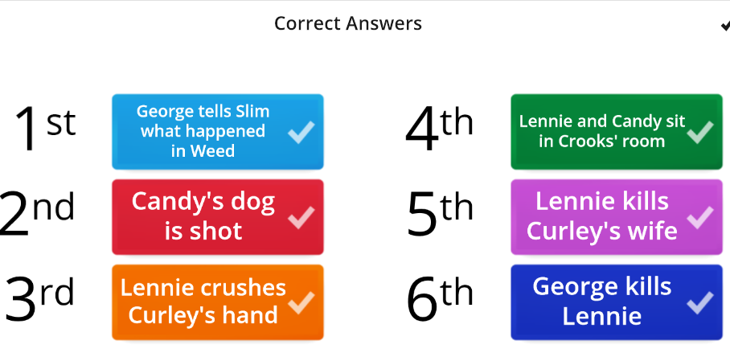

Voir fichier annexe : a timeline

Of Mice and Men - Plot summary

1. Why does Lennie have a dead mouse with him at the start of the book?
He collects dead animals
He likes to stroke soft things
Lennie likes to stroke soft things so keeps the mouse in his pocket so he can pet it.

He thinks it is a puppy

2. Where does George tell Lennie to go if he gets into trouble?
To the clearing by the river that they go to in Chapter one
George tells Lennie to look carefully at the clearing and remember it so that he can return and hide in the brush if he gets into trouble. He does not tell him to go back to Weed.

Back to Weed
To the bus stop

3. Why did George and Lennie have to leave Weed?
The job they were doing had finished
They ran out of money
Lennie was accused of raping a girl after feeling her dress and not letting go
They had not finished working but had to run away before they were caught because Lennie was accused of raping a girl after feeling her dress and not letting go.

4. What makes the Boss suspicious of George and Lennie?
He thinks George might be taking advantage of Lennie because he does not let him speak
It makes him suspicious that George answers for Lennie and does not allow him to speak

He is worried that they will flirt with his son Curley’s wife
He thinks they are not good workers

5. What is the significance of the shooting of Candy’s dog?
It shows that Carlson hates Candy and wants to hurt him
It suggests that on the ranch, things that have no value are destroyed
Carlson does not want to upset Candy. He doesn’t think of the dog as being important because it is so old and he considers it kinder to put it out of its misery. This shows how little life is valued on the ranch.

It demonstrates that the men don’t want to have any dogs on the ranch

6. Why doesn’t Crooks want Lennie to go into his room?
He is angry that he is not allowed to go into the white men’s room
Crooks does not like Curley’s wife and tells her to leave when she does go into his room later on, so he does not want her there. He is bitter and lonely because he has been treated badly because of his colour.

He hates Lennie
He is hoping that Curley’s wife will come in and doesn’t want anyone else there

7. Why does Curley’s wife go to Crooks’s room when she is not wanted there?
She is attracted to Candy
She is lonely and would rather speak to anyone than be on her own
Curley’s Wife does not have anyone to speak to on the ranch so she seeks out the men in order to have some human contact.

She wants Crooks’s help with some farm work

8. Why does Crooks want to be involved with the dream of the farm?
He wants to grow his own vegetables
He wants to pet rabbits
He wants to live somewhere where he feels like he will belong
Crooks has spent his like feeling like he is excluded and being discriminated against because of his colour. He wants to live somewhere that he part owns, so that he will have a sense of belonging.

9. What is Curley’s wife’s dream?
To marry Slim To be a movie star To have children
She wants to be a famous movie star and said that she had the opportunity to do this but her mother stopped her.

10. Why does George kill Lennie?
He would prefer to kill Lennie painlessly and quickly than allow Curley to hurt him
George knows that Curley will treat Lennie badly when he finds him and wants to protect his friend. He thinks the only way to stop Curley is to kill Lennie himself.

He is angry with Lennie for killing Curley’s wife
He thinks Lennie will kill the men if they find him

Source:

https://www.bbc.com/bitesize/guides/zyqyxsg/test

1. John Steinbeck was born in ... in California

Salinas
Sacramento
San Diego
Los Angeles
2. In 1925, he ...
left his wife
quit
retired
dropped out of Stanford
3. John Steinbeck worked as a manual laborer before becoming a writer
True False
4. His works often dealt with social and economic issues
False True
5. In 1962, he was awarded the ...
Nobel Prize in Literature
Nobel Prize in economics
the Pulitzer Prize
the Booker Prize
6. He won a Pulitzer Prize and a National Book Award for ...
East of Eden
Of Mice and Men
The Grapes of Wrath
Cannery Row
7. He worked as a war correspondent during World War I
False True
8. Of Mice and Men was published in ...
1934
1935
1930
1937
9. John Steinbeck was married 3 times
False
True
10. In 1929, the crash on Wall Street started ...
World War II
The Great Depression
the Civil War

Complete George’s portrait with the following words
stressful / anger / friends / caring responsible / regrets / disability / trouble / responsibility / frustrating / dream / protective / related
George is a protective man, who has been caring for his friend Lennie for a long time. The two men are not related but have been friends since they were children, so as well as enjoying his company, George also feels responsible for his welfare. George often talks to Lennie about their dream.
Due to Lennie’s mental disability, George has to take responsibility for him and finds this stressful and frustrating at times, due to Lennie getting into trouble. This results in outbursts of anger towards Lennie at certain points in the novel, although George regrets these quickly

Complete Lennie’s portrait with the following words
aware / difficult / strong / mental / obsessed / sweet-natured / harm / pleasures / violence innocent / control / dependent

Lennie is George’s friend and the two travel together. Lennie has a mental disability, making him dependent upon George to manage day to day life in the difficult environment in which they live and work.
Lennie is physically very strong (so his name is ironic), but cannot control himself, leading to escalating acts of accidental violence through the book. He is obsessed with stroking soft things, such as animal fur. He does not mean to cause harm but is not aware of his own physical power.
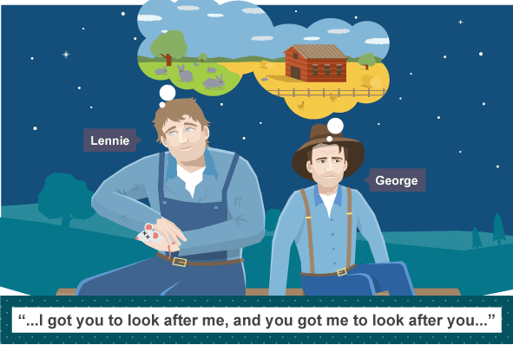
Lennie is very innocent and sweet-natured; he always means well and is focused on simple pleasures.

Circle the themes you think are most relevant to Of Mice and Men
Human fragility love marriage

Fathers and sons racial prejudice nature dreams and reality

Country life money loneliness ambition

Hope friendship despair violence

Form and structure of the book
Of Mice and Men is written in the form of a novella, which is fictional and shorter than a novel but longer than a short story.
The book has a third person narrator, but there is less narration than in traditional prose fiction and the action often moves on through the characters’ dialogue. Although the narrator is omniscient, they do not give a lot of insight into the characters’ thoughts and feelings, as some omniscient third person narrators do. Instead, this is suggested to the reader through the characters’ actions and what they say. This makes the style of writing quite direct and unemotional, which reflects the way that the characters live and relate to each other.

Of Mice and Men can be compared to a play – like a play, it has a precise structure.
In what other ways is the book similar to a play?
Choose Not similar or Similar for each of these statements:

 | NS | VS
- There are a series of ‘scenes’, which follow on from each other, building tension |  | x
- We are told characters’ thoughts without them being spoken out loud | x
- Each scene has a clearly identifiable setting |  | x
- There is a lot of dialogue and speech |  | x
- There are several very dramatic scenes |  | x
- it has a small number of characters |  | x
- It focuses more on dialogue and less on description |  | x
- The book is divided into sections and scenes has three sections, like acts - each a pair of chapters; like scenes. |  | x
- Each chapter starts with an overview of the setting of the ‘scene’, similar to stage directions in a play |  | x
- The book has a third person narrator | x

There are a lot of clues which foreshadows the ending. Put them in the (time) order in which they happen. Number the events below 1 to 6.

- Lennie’s killing of mice 2
- What happened between Lennie and the girl in Weed 1
- The shooting of Candy’s dog 3
- The killing of the puppy 6
- Curley’s wife interest in Lennie when she comes to Crook’s room 5
- The fight with Curley showing Lennie’s vast strength 4

