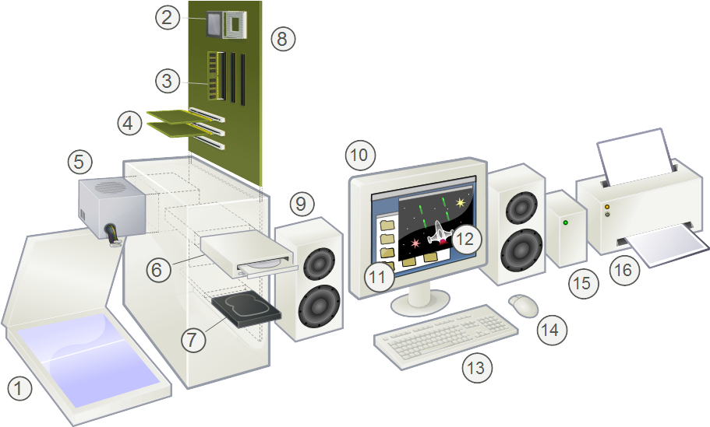
Can you name them?

TEACHER

https://commons.wikimedia.org/wiki/File:Personal_computer,_exploded_6.svg

1 Scanner
2 CPU (Microprocessor)
3 Main memory (RAM)
4 Expansion cards
5 Power supply unit
6 Optical disc drive
7 Hard disk drive (HDD)
8 Motherboard
9 Speaker
10 Monitor
11 System software
12 Application software
13 Keyboard
14 Mouse
15 External hard disk
16 Printer

