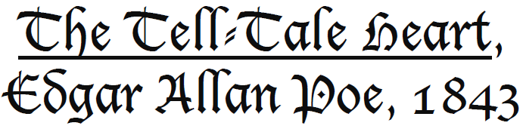
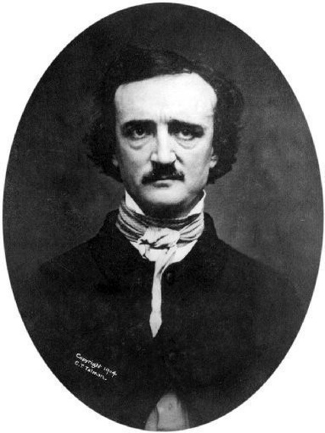
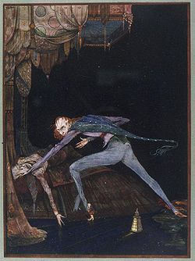
_____________

STUDY GUIDE

_____________

See Padlet https://fr.padlet.com/isabelle_saintigny/82rsfvy53e9n

Pour un corrigé, contacter l’auteur à : isabelle.saintigny@gmail.com

Investigate E.A.Poe’s life and answer the questions

Are these sentences about Edgar Allan Poe true or false? Correct the false ones
- He was born in Maryland in 1809
- He died at 40.
- He published The Raven in 1850.
- He was paid $900 for the poem.
- He’s well-known for writing comedies.
- He married his cousin Virginia Clemm when she was 13.
- Virginia died of tuberculosis.
- Poe died of a heart attack.

Read the whole text. Underline the words you don’t know. Try to guess their meaning from the context before checking them in a dictionary.
You can use an online dictionary: www.wordreference.com or https://www.collinsdictionary.com/
Take notes!
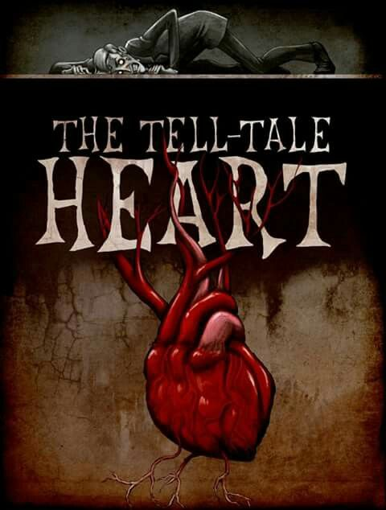
The narrative technique

1- Identify the genre of the short story:

2- Identify the type of narrator:

3- Who are the characters?

4- Identify the climax of the story:

5- What event is the turning point?

Comprehension questions

Go to https://create.kahoot.it/details/the-tell-tale-heart-eapoe/efa5b800-737f-402b-b981-94c51691f397to play the quiz online!

1- What is the narrator trying to convince his listeners?

2- What sense was acute at the beginning of the story?
Smell Sight Hearing Touch

3- What was the reason why the narrator killed the old man? Quote a sentence to justify.
Forhisgold Because of his pale blue eye Because the old man wronged him

4- What did he do every night? What time of night was it?

5- Whycouldn’tthenarratorkilltheoldmanthefirstnight? What finally causes him to commit the act?

6- How many times did the old man scream?
none once twice three times

7- How did the narrator describe the groan he heard?
One of pain One of grief One of mortal terror

8- How did the man kill the old man?
By smothering him with a pillow By choking him with his hands By pulling the heavy bed over him

9- After killing the old man, the narrator …
buried the body put the body under the bed cut the body into pieces

10- Where did the narrator conceal the body?
Under the planks in the floor Intheoldman'sgarden In theoldman's closet

11- Who knocked on the door? Why were they there?

12- When there was a knock at the door after the old man's death, the man opened the door with a light heart. Why?
He had thought up an alibi or cover story for what had happened
He had a weapon on him
He thought everything was cleaned up with no evidence of blood

13- How did the police find out the man had killed the old man?
A neighbour said he saw the man kill the old man
The police found the body on their own as they searched the house
The man confessed the crime

14- Finally, why did the narrator confess the crime?
The murderer confessed because …
The police caught him red-handed
He was full of remorse
He could hear the old man’s heart

15- What was the tell-tale heart?
Theoldman'sheart Theman'sbeatingheart The heart of the unperceived shadow

Say if the following statements are true or false. Justify each time with a quote.

1- The plan to murder the victim was organised very quickly.

2- The narrator and the old man are enemies.

3- It took the narrator a whole week to kill the old man.

4- The man denied murdering the old man

A brief summary

This is a summary of the Tell-Tale Heart but there are some mistakes in it. Correct them according to the story.

This short story written by Edgar Allan Poe in 1825 is about a man who wanted to kill an old man with whom he lived because he wanted his money. He planned the murder very carefully. He went into the old man’s room every night for ten nights. On the last night as the old man opened his eyes because he had heard a noise, the murderer saw him wide awake with his eye opened and stabbed him, dismembered him and hid the body in the old man’s garden.
After a passer-by had heard a gunshot, the police came to the house and searched it. While the police and the narrator were arguing, suspecting the man was the killer, the man started hearing the sound of a heartbeat.
The police finally discovered the body although the murderer denied killing the old man.

Choose the best adjective to complete the sentences about the story
Scared / relaxed / insane / furious / cold-blooded / erratic / kindly / over-confident / unsuspicious /nervous / good-humoured

At the opening of the story, the narrator feels ___________ and tries to convince the readers that he is not ___________.
The week before the old man’s murder, he treated his victim ___________and the old man was ___________of the narrator.
On the night of the murder, when the narrator opened the lantern and saw the old man's open eye, he got ___________.
When the old man woke up, the narrator knew he was ___________.
After the murder, the narrator was ___________and even started a conversation with police who had come to search the house. He was ___________and even very ___________and ___________until he lost control of the situation and his behaviour became ___________.

Analysis questions

A “perfect” gothic short story

1- What are the main gothic conventions used in the story. What effect are they supposed to have on the reader?
Where is the story set? Is it the traditionally “Gothic”?

2- Show how terror evolves in the story. Pay attention to the following elements to answer.

3- Give examples of how Poe creates suspense in the story?

4- What does the story's title mean?

5- Pick out some words he uses to convince the reader he is not mad

6- The narrator claims he is not mad. What evidence do we have that he is?

7- Show that at times he displays signs of euphoria:

8- Show his excessive confidence when confronting the police:

9- Show that gradually, the man lost control of the situation:

7- Whom do you think the speaker is addressing in the story?

Explain the ironic twist in the story:

Literary devices

Find examples of the following literary devices in The Tell Tale Heart:

a. Simile: a comparison using “like or as.”

b. Personification: giving human characteristics or actions to something that is not human.

c. Alliteration: consonant sounds that repeat themselves in a line of prose or poetry.

d. Irony: is the contrast between what is expected or what appears to be and what actually is.

Symbolism in the Story

1- The two symbols in the story are the eye and the heart. What might these two symbols represent?
*Notice the identical pronunciation of “eye” and “I” /ai/.

Reacting to the text

In “The Philosophy of Composition” Poe argues that all the elements in a literary work (theme, setting, mode of narration, symbols, etc) should work together in the service of a particular “effect”. His texts thus pursues an emotional response/”effect” on the part of the reader. Has “The Tell-Tale Heart” had an “effect” on you?

