GUNS WITH HISTORY KEYS
1. Read the information on the screen.
- What do most people buy a gun for ?
Most people buy a gun in order to feel safer/ to protect themselves and their families against criminals/ to use it as a deterrent/ …
- What are the risks of having a gun at home?
Having a gun at home is dangerous. Gun owners are more likely to kill or get killed.
- What are the campaigners’ goals?
The campaigners want first-time gun buyers (people who have never bought a gun before) to think twice before doing it. This is an awareness campaign to sensitize people about the dangers of guns.
2. Focus on the experiment.
- What did the campaigners do?
They built a fake gun shop in NYC.
- What technical device is used? Why?
Cameras were hidden to capture the buyers’ reactions.
- What is special about the objects sold there?
The guns all have history. Each has a tag which reads the history of the gun, where, when, how, by whom it was used and who the victims were.
- What sort of customers are there? What reasons for buying a gun do they give?
There are people from all walks of life, all ages, men, women, …
They all want to buy a gun for safety, for protection.
- What are the customers’ reactions when they hear the stories?
They are appalled (=horrified); surprised; shocked; sad.
They change their minds. They don’t want to buy a gun any more.

Information on the screen:
Over 60% of Americans think owing a gun will make their lives safer.
In fact, owing a gun increases the risk of homicide, suicide and unintentional death.
To make first-time gun buyers think twice, we did the unthinkable. We opened a gun shop in NYC.
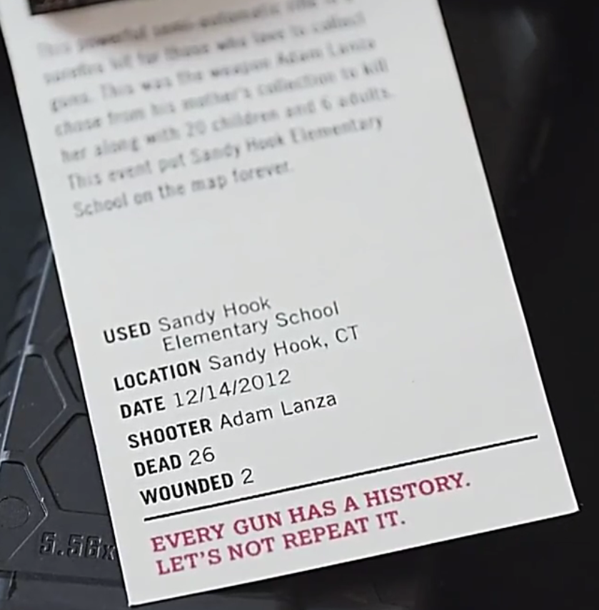
People’s reactions after the experiment:
“I was pretty blind sided (pris de court, pris par surprise) just the entire history of every gun in the store.”
“Well maybe I should think I’m not gonna buy a gun.”
“This made me think twice and I’m not gonna buy one.”
“It is one of our rights, but my opinion’s definitely changed, I don’t feel safe with a gun.”
“I don’t wanna be the Walmart case.”

the Walmart case: Veronica Rutledge, 29, was shot in the head and died instantly after her two-year-old son reached into her purse and got a hold of a 9mm Smith & Wesson handgun during a shopping trip. She had a legal permit to carry a concealed weapon (in a purse).

